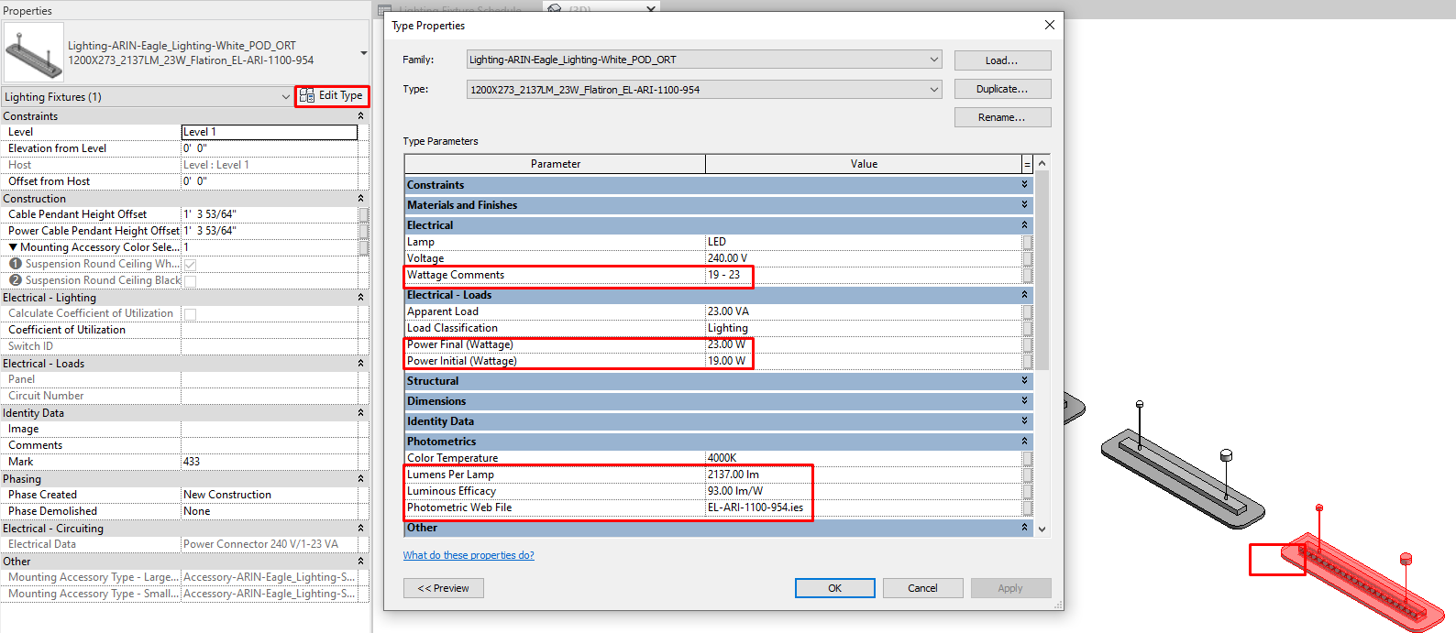
Figure 1- Click on a lighting fixture, click Edit Type, view information such as Wattage Comments, Initial/Final Power, Luminous Efficacy (lumens/watt), and an informational parameter for IES file.
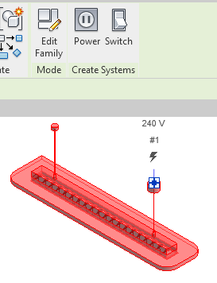
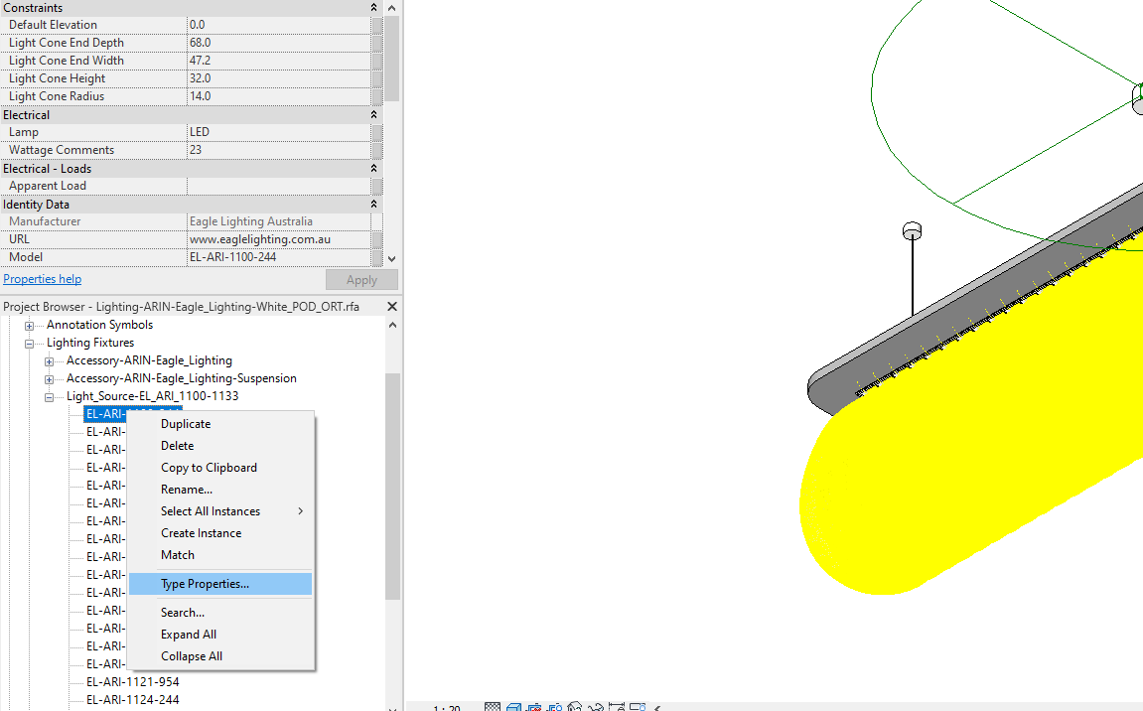
Figure 2 - To find the actual embedded IES file, click on a lighting fixture and select Edit Family along the top of Revit. From there, navigate to the Light Source Families in the Project Browser. Right Click to edit Type Properties. From there you can see the IES file.
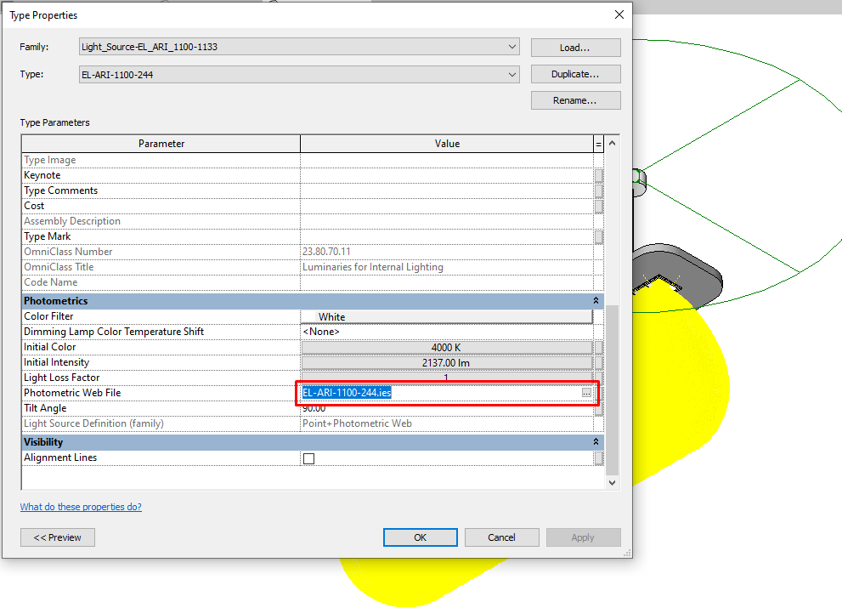
Figure 3 - Here is the IES file. this is different from the Informational parameter that shows the same information without editing the family.

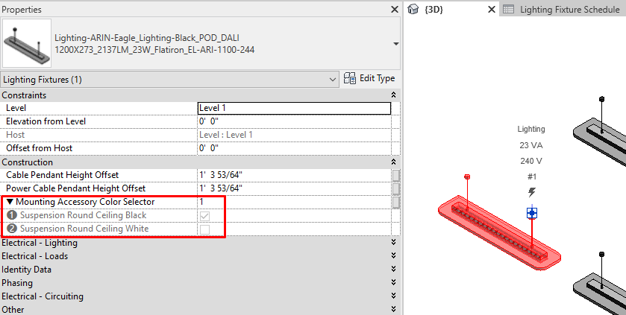
Figure 4 - We have adjusted how the mounting accessories display in the families. Now the user can select Black or White.
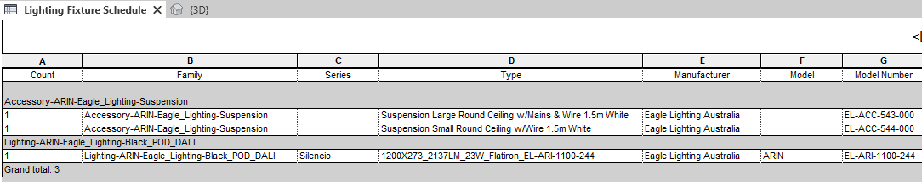
Figure 5 - Here is what it looks like in a bill of materials if just one lighting fixture has the box selected for White.
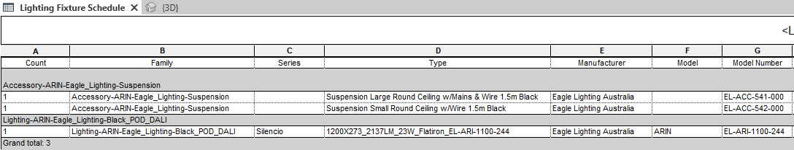
Figure 6 - Here is what it looks like in a bill of materials if just one lighting fixture has the box selected for Black.

